专英论文要求

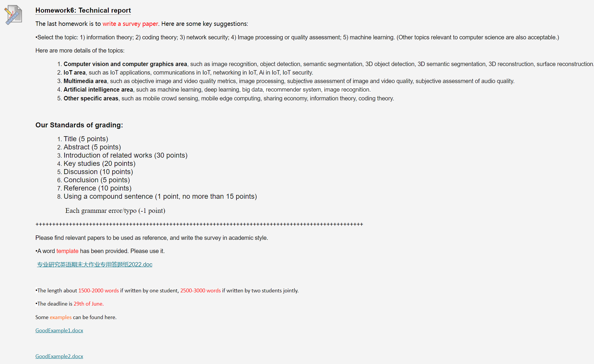

The last homework is to write a survey paper. Here are some key suggestions:

•Select the topic: 1) information theory; 2) coding theory; 3) network security; 4) Image processing or quality assessment; 5) machine learning. (Other topics relevant to computer science are also acceptable.)

Here are more details of the topics:

1. **Computer vision and computer graphics area**, such as image recognition, object detection, semantic segmentation, 3D object detection, 3D semantic segmentation, 3D reconstruction, surface reconstruction.
2. **IoT area**, such as IoT applications, communications in IoT, networking in IoT, Ai in IoT, IoT security.
3. **Multimedia area**, such as objective image and video quality metrics, image processing, subjective assessment of image and video quality, subjective assessment of audio quality.
4. **Artificial intelligence area**, such as machine learning, deep learning, big data, recommender system, image recognition.
5. **Other specific areas**, such as mobile crowd sensing, mobile edge computing, sharing economy, information theory, coding theory.

**Our Standards of grading:**

1. Title (5 points)
2. Abstract (5 points)
3. Introduction of related works (30 points)
4. Key studies (20 points)
5. Discussion (10 points)
6. Conclusion (5 points)
7. Reference (10 points)
8. Using a compound sentence (1 point, no more than 15 points)

                 Each grammar error/typo (-1 point)

+++++++++++++++++++++++++++++++++++++++++++++++++++++++++++++++++++++++++++++++

Please find relevant papers to be used as reference, and write the survey in academic style.

•A word template has been provided. Please use it.

[专业研究英语期末大作业专用答题纸2022.doc](https://elearning.szu.edu.cn/bbcswebdav/pid-752462-dt-content-rid-6646650_1/xid-6646650_1" \t "https://elearning.szu.edu.cn/webapps/assignment/_blank)

•The length about 1500-2000 words if written by one student, 2500-3000 words if written by two students jointly.

•The deadline is 29th of June.

Some examples can be found here.

[GoodExample1.docx](https://elearning.szu.edu.cn/bbcswebdav/pid-752462-dt-content-rid-6662453_1/xid-6662453_1" \t "https://elearning.szu.edu.cn/webapps/assignment/_blank)

[GoodExample2.docx](https://elearning.szu.edu.cn/bbcswebdav/pid-752462-dt-content-rid-6662454_1/xid-6662454_1" \t "https://elearning.szu.edu.cn/webapps/assignment/_blank)

H

 ++++++++++++++++++++++++++++++++++++++++++++++++++++++++++++++++++++++++++++++

My topic:On-Skin interaction

**资料！**

**Senskin&skinwatch**

**Senskin:**  
我们提出了一种传感技术和输入方法，该技术使用通过附着在人体上的薄带式装置估计的皮肤变形，其外观在日常生活中似乎可以社会接受。输入接口通常需要反馈。SenSkin提供触觉反馈，使用户能够知道他们正在触摸皮肤的哪个部分，以便发出命令。用户在开始输入操作之前找到了可接受的区域，可以继续输入命令，而无需收到显式反馈。我们开发了一种带有两个臂带的实验装置，用于感测施加在皮肤上的三维压力。在没有触觉障碍物的情况下对裸露皮肤的切向力的感应以前从未实现过。SenSkin在测量施加到皮肤（例如前臂或手指）的定量切向力方面也很新颖。使用红外（IR）反射式传感器，因为它的耐用性和价格低廉使其适用于日常人体传感目的。位于两个臂带上的多个传感器允许切线施加到要感知的皮肤尺寸的 ial 和法向力。输入命令是使用支持向量机 （SVM） 学习和识别的。最后，我们展示了一个实现此输入法的应用程序。